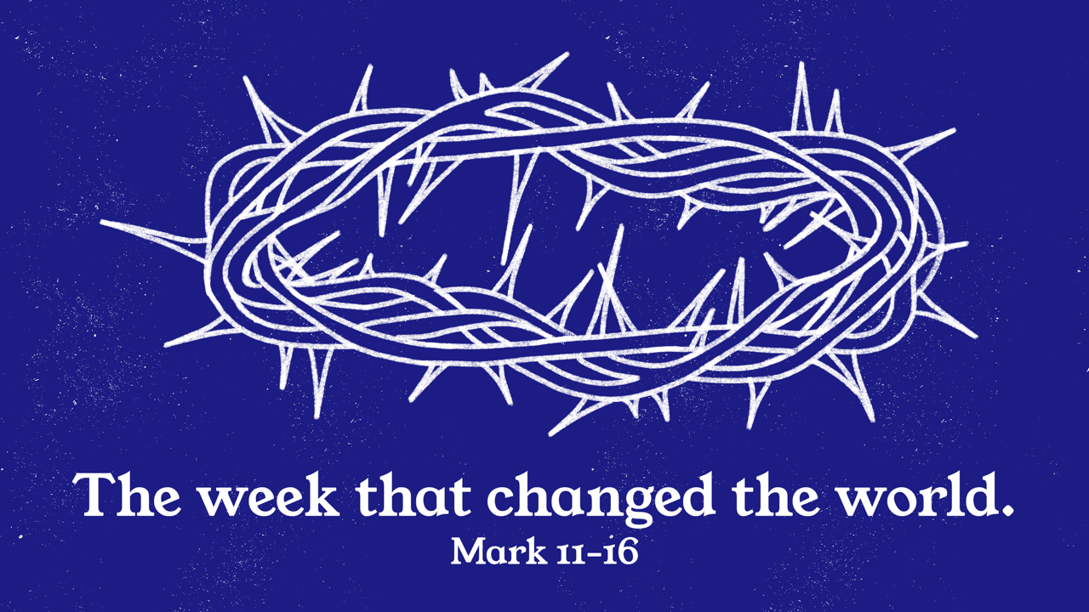

Growth Groups Material
(9 studies on Mark 11-16)
Feb-Apr 2026



Teaching Schedule
In our gatherings we will work through an 11-part series, which includes the Easter Weekend:  Note: This material contains 9 studies, corresponding to the first 9 sermons in the series. The remaining two weeks correspond to the Easter Weekend. | 29 Jan-1 Feb  5-8 Feb  12-15 Feb  19-22 Feb  26 Feb-1 Mar  5-8 Mar  12-15 Mar  19-22 Mar  26-29 Mar  3 Apr (Good Friday)  5 Apr (Easter Sunday) | Mark 11:1-11  Mark 11:12-25  Mark 11:27-12:12  Mark 12:13-44  Mark 13:1-37  Mark 14:1-31  Mark 14:32-52  Mark 14:53-72  Mark 15:1-15  Mark 15:16-41  Mark 15:42-16:8

Booklet Contents
Introduction | p.3
Study 1 (Mark 11:1-11) | p.4
Study 2 (Mark 11:12-25) | p.6
Study 3 (Mark 11:27-12:12) | p.8
Study 4 (Mark 12:13-44) | p.11
Study 5 (Mark 13:1-37) | p.13
Study 6 (Mark 14:1-31) | p.15
Study 7 (Mark 14:32-52) | p.18
Study 8 (Mark 14:53-72) | p.20
Study 9 (Mark 15:1-15) | p.22
Lifeboat list activity | p.24

Additional Resources
We’ve put together some additional resources that might help you as you make your way through this series:  https://www.jannalianglican.org.au/mark-11-16 | 

Introduction

The Gospel of Mark is the shortest and most action-packed of the four Gospels, offering a fast-paced account of Jesus’ life, ministry, death, and resurrection. Likely written between A.D. 50–70, Mark’s Gospel is believed to be based on the eyewitness testimony of the Apostle Peter and was recorded by Mark, who was a companion of both Peter and Paul.

Over the last two years we’ve worked our way through Mark book, from chapter 1 to chapter 10. Our various series’ titles give us a sense of what we’ve learnt so far. Jesus is both strong and kind (chapters 1-4). Are we seeing Jesus clearly (chapters 5-9)? Will you follow Jesus in the way of sacrificial service (chapters 10-11)?

Mark 11–16 takes us into the final, climactic week of Jesus’ life. The week that truly changed the world. From his royal entry into Jerusalem to his shocking death and victorious resurrection, these chapters reveal what kind of king Jesus really is. We see his authority challenged, his love poured out, his mission fulfilled, and his power displayed over sin and death. As you study these passages, you’ll be invited not just to watch the story unfold, but to respond—who is Jesus to you, and how will you follow him?

As we approach Easter, when the Mark teaching series will end, our prayer is that you will be moved again by the sin-bearing death of our innocent saviour, for you. And that you will pray and take opportunity to share this message with others, so that they too might be saved.

Study 1 | Mark 11:1-11

Introduction
- Have you ever been part of a big public celebration like a ticker-tape parade? Tell the group about it. What is the point of events like this?

Read and Discuss
- Read Mark 11:1-11. How would you describe the scenes which took place as Jesus entered Jerusalem?

- Mark is intent on telling us about Jesus’ mode of transport – the colt? Read Zechariah 9:9-10. What is the significance of Jesus riding on the colt/donkey?

- What do the shouts of the crowd tell us about Jesus and his mission?

Reflect and Apply
- Jesus’ deliberate orchestration (and knowledge) of getting the colt, teaches us that he was in complete control of his destiny. How does this give us confidence and comfort, knowing that Jesus was in control of his journey to the cross?

- The crowds recognized Jesus as a King and laid their clothes down on the path to be trampled on? What are some ways in our lives that we could demonstrate a similar level of worship and submission to Jesus?

- Verses 9 and 10 convey a real sense of joy at the coming of King Jesus. Do you feel joy when you contemplate the salvation Jesus has won for us? How can we cultivate this kind of joy?

Study 2 | Mark 11:12-25

Introduction
- Is it right and good for Jesus to lose his temper? Why or why not? Discuss.

Read and Discuss
- Read Mark 11:12-26. In his style of writing, Mark is known for using a ‘sandwich structure’ – linking two ideas together (bread-filling-bread). What is the bread in this section? What is the filling? How might they be related?

- How is the condition of the fig tree a picture of the spiritual condition of the temple. How is the fate of the fig tree a picture of the final end of the temple?

- Read Isaiah 56:6-7 and Jeremiah 7:11. What was the Jewish temple meant to be like? What had gone wrong?

- Read verses 21-25 again. Is Jesus really saying that we’ll be given anything we pray for? What might Jesus be saying, given his recent judgment against the temple?

Reflect and Apply
- In what ways can the church today fail to fulfil our role as ‘God’s temple’? What do we Christians need to do to enable all nations to find forgiveness and meet with God?

- Do you think God remains concerned with the disconnect between Christians who do the right religious things but don’t bear fruit in their living? How should we respond if we notice that inconsistency in our own lives?

- In what ways could the message of verses 21-25 be considered good news for us?

Study 3 | Mark 11:27-12:12

Introduction
- What attributes make a leader worthy of following?

Read and Discuss
- Read Mark 11:27-33. Recall the response of the Jewish leaders to the scene in the temple (Mark 11:18). What do you think is behind the approach to questioning Jesus?

- What impresses you about Jesus’ response?

- Read Mark 12:1-12. Who do the different characters/story elements represent in reality (vineyard owner, vineyard, tenant farmers, servants, son). What point is Jesus making by speaking this parable?

- What could be the real life meaning of the comment at the end of the parable – “He will…give the vineyard to others.”

Reflect and Apply
- Does this parable explain the behaviour of Israel and its leaders towards God, or the behaviour of humanity at large?

- How does this parable help us appreciate the absolute unreasonableness, and evil of rejecting Jesus?

- What is the end result for anyone that opposes Jesus?

Page left intentionally blank (use for notes, prayer points etc)

Study 4 | Mark 12:13-44

Introduction
- Reflect on the last few weeks of talks/studies. Do you have a “one thing” that you have recorded somewhere and can share. Either way, share one thing that has stood out to you from chapters 11-12 so far?

Read and Discuss
- Read Mark 12:13-37. There are four scenes here, following a similar pattern. Can you identify for each scene:
  - Those asking the question;
  - The question itself; and
  - Jesus’ answer

- Do you notice any important differences between each scene?

- Read Mark 12:38-44. Who is being contrasted in these two passages? What do you think Mark wants his readers to take away from this contrast?

Reflect and Apply
- Would you say that the love of religious titles or positions, without any real love for God, remains a problem today? Where do we see it?

- What would the signs in our lives be, if like the scribes we did religious things in order to be seen and praised?

- What might it look like for us to follow the example of the widow in verses 41-44?

Study 5 | Mark 13:1-37

Introduction
- What examples do you see today of people looking for signs to correlate with God’s word? What is tempting about doing this?

Read and Discuss
- Read Mark 13:1-37. What future troubles or deceptions are the disciples warned about??

- Amongst scholars there are different views about what future event is being referred to by Jesus in this chapter. The main options are:
  - the death and resurrection of Jesus;
  - the destruction of Jerusalem and the temple by the Romans in AD70; or
  - the second coming of Jesus.
Discuss which of these three options seems the best way to understand the passage? What can you point to in the passage that supports your argument.

- Should Christians of our own generation expect a hard time for being followers of Jesus? What is the message of this chapter for us?

Reflect and Apply
- When the days of tribulation come (verse 18) it must have felt like/will feel like God is not in control of things. What lesson does this chapter give us when we feel that God is not in control?

- Jesus applies what he has been saying for us in verses 32-37. How should we prepare for the coming of Christ?

- How can we remain content in our (lack of) understanding – not knowing all the answers? For example, in this case, it’s hard to be precise about what events are being described by Jesus.

Study 6 | Mark 14:1-31

Introduction
- Imagine you knew the time and circumstances of your death? What would you do with that information? How would you feel?

Read and Discuss
- Read Mark 14:1-31. List all the different characters (or groups of characters). How should we assess each of them, and their response to Jesus?

- What does Jesus already know about his death? List all the aspects of his death (how it comes about, it’s meaning etc.) that Jesus already understands. What is unusual about the way he handles this knowledge?

Reflect and Apply
- Should we be more extravagant in our worship of Jesus, like the woman in Bethany. How could we do this?

- How does Jesus’ knowledge of his impending death demonstrate his love for us?

- What is the significance of the Passover for understanding the meaning of Jesus death?

Page left intentionally blank (use for notes, prayer points etc)

Study 7 | Mark 14:32-52

Introduction
- Reflect on the last few weeks of talks/studies. Do you have a “one thing” that you have recorded somewhere and can share. Either way, share one thing that has stood out to you from chapters 13-14 so far?

Read and Discuss
- Read Mark 14:32-42. What contrast is presented between Jesus and the disciples. What might the theological significance of this be, as Jesus approaches the cross?

- How does Jesus’ prayer to the Father demonstrate his absolute trust?

- Read Mark 14:43-52. The average person would probably resist arrest. Why does Jesus submit to his arrest?

Reflect and Apply
- Are their situations in your life where you could/ought to be praying to God: “not what I will, but what you will”? What are they? Share with the group if you are comfortable doing so. In other words – are there hard things you are being called to endure, in order to obey God?

- How does Jesus’ resolve to go the cross, despite his trepidation, demonstrate his love for us? His love for God the Father?

- The behaviour of the man in verse 51 calls us to consider how we might have responded to Jesus’ arrest if we were present? What do you think you would have done? Why?

Study 8 | Mark 14:53-72

Introduction
- Have you ever publicly denied being a follower of Jesus, or twisted the truth about your faith? If you are willing, share with the group the circumstances of this occasion and how you felt about it afterwards.

Read and Discuss
- Read Mark 14:53-65. What is the aim of the of the assorted Jewish authorities in this scene?

- What question is put to Jesus in verse 61? What is Jesus’ response?

- Jesus’ response to this question, “I am”, in verse 62, seems familiar and normal to us. Jesus is explicitly claiming to be the Son of God! What is the response from the Jewish leaders to this claim? Why?

- Read Mark 14:66-72. Peter’s denial returns us to the theme of the disciple’s failures to resist temptation (see Mark 14:38). What might the theological significance of this be, as Jesus approaches the cross?

Reflect and Apply
- Skeptics sometimes say that Jesus never claimed to be divine, and that Christians have misunderstood him. How does this passage correct that myth?

- Jesus was willing to speak the truth here, despite the serious costs that would follow. Peter does not? Are there issues or situations in your life which tempt you to withhold the truth (or lie) because the prospective costs? How does Jesus’ example train us to be truthful?

Study 9 | Mark 15:1-15

Introduction
- Reflect on the last few studies covering chapter 14. What makes Jesus attractive in these scenes?

Read and Discuss
- Read Mark 15:1-5. What is Pilate so surprised about in these verses?

- How would you describe Jesus’ manner, in response to the accusations and questions he faced?

- Read Mark 15:6-15. What does Mark reveal about Pilate’s concerns around Jesus’ execution? What do you think Mark is trying to show us?

Reflect and Apply
- Throughout his arrest and trial, Jesus suffers unimaginable injustice. He is innocent of wrongdoing yet sentenced to death. Have you been the victim of injustice, unfair accusations etc. What is your natural reaction? How could we emulate Jesus’ example?

- The calls of the crowd to have the guilty Barabbas released and Jesus crucified are simply absurd! How does this moment exemplify all rejection of God and all human sin?

- What theological truths does the exchange of Jesus with Barabbas convey to us so vividly?

- Take a moment to reflect on our journey through Mark 11-16. What’s one thing that has stood out to you or impacted you in some way. Tell the group about it.

Praying for our Lifeboat lists (members book page 18)

 | We know that everyone’s greatest need in life is to be reconciled with God through Jesus so that their sins can be forgiven. We want lost people to be saved, and know the eternal hope of salvation, rather than perish under God’s judgment.
A tool we use to help us pray regularly is our lifeboat list. These are bookmarks upon which we can list three people that we’re deliberately praying for and actively working towards sharing Jesus with.  In our groups, it would be excellent to share with each other who is on our lifeboat lists, and pray together for each of these people, and our efforts to reach them.  You might like to use the next two pages to record the name of the people you are praying for. |  | 

Praying for our lifeboat lists

Group Member | Lifeboat list

Praying for our lifeboat lists

Group Member | Lifeboat list

Page left intentionally blank (use for notes, prayer points etc)



